|  |  |
| --- | --- |
|  | ***Patuakhali Science and Technology University*** |

Assignment on

***“***How to compiling and run java program  through IDE like Netbeans, IDEAJ  eclipse etc.***”***

Course Code: CCE-122

Course Title: Object Oriented Programming

Level - I; Semester - II

|  |
| --- |
| **Submitted By**  **Name: M.D. Sakibul Islam Shovon**  **ID:** 2302056  **REG:** 11834  **Session:** 2023-2024  Faculty of Computer Science and Engineering |

|  |
| --- |
| **Submitted To**  **Prof. Dr. Md. Samsuzzaman**  Professor of Computer and Communication Engineering Department  Faculty of Computer Science and Engineering |

**Compiling and run java program through IDE (NetBeans)**

1.       Install NetBeans software from any browser.

Search NetBeans Downloadl



2.       Install Apache NetBeans 26

3.       Check the java JDK install in the pc/laptop.

Check:

Step 1: Click Windows Button.

Step 2: Search CMD or command promot.

Step 3: type → java –version.

Step 4: If the message is –

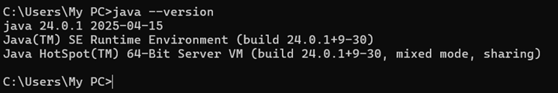

then the java JDK is install in my pc/ laptop.

Else the message is others type then the java JDK isn’t install in my PC/ Laptop.

Then install java JDK from any browser.

4.      Search java JDK download. Then go to the first link.

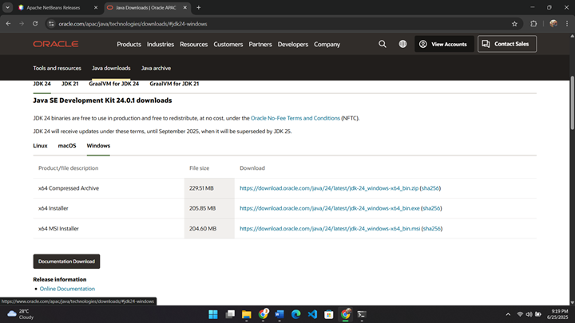

5.      Download the java JDK.

6.      Install Java JDK.

7.      Set bin path. Go to File explorer → C drive → program files → java → jdk24 → bin. Then copy the bin address.



10. Set up the Environment for java JDK.

      Step 1: Click Windows Button.

      Step 2: Search Environment variables.

Step 3: Click Environment variables → Select path → New(User variable for my  pc) → ok → ok → ok.

     12. Open NetBeans.

     13.  Click File.



     14.  New Project.

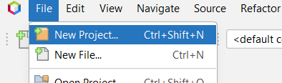

     15.  Select Java with ant → java Application. Click Next. 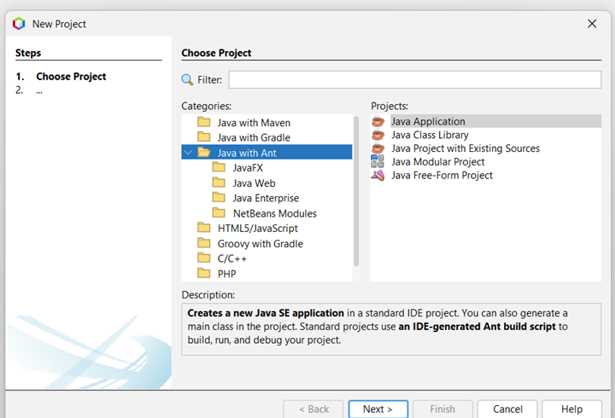

16. Edit file name → Choose File Location → Finish

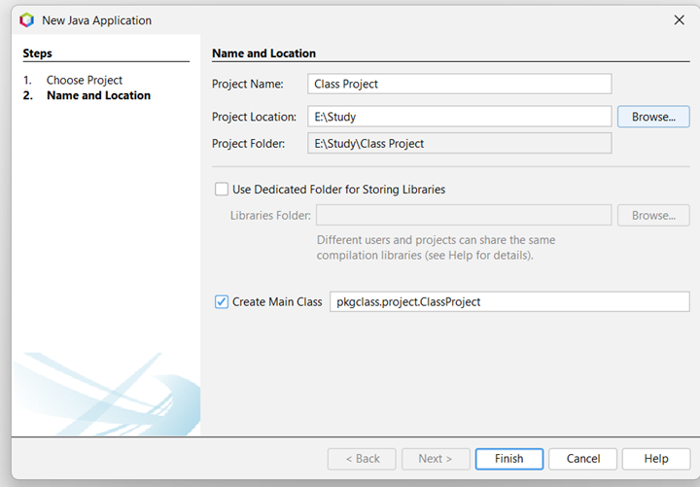

17. Write a java code.

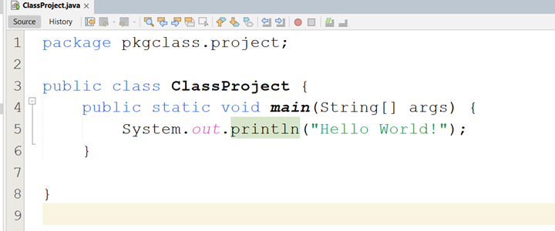

18. Click the run button.



19.  Output:

